oracle spatial介绍

在命令提示符中导入map_large.dmp

C:/>imp sde/sde@orcl file=c:\test\map_large.dmp ignore=y full=y

C:/>sqlplus sde/sde@orcl

—— 查询Oracle Spatial元数据视图的结构

SQL>describe user_sdo_geom_metadata

SQL>select * from user_sdo_geom_metadata;

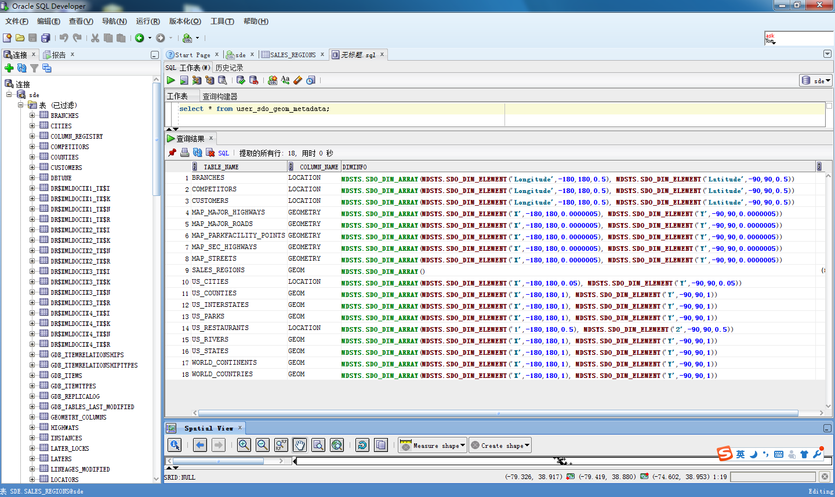

—— 查询mdsys.cs_srs的结构

SQL>describe mdsys.cs_srs

SQL>select * from mdsys.cs_srs;

—— 查询包含以“GEOGCS”开头的WKTEXT列，从CS_SRS表中获得现有的大地坐标系（经纬度表示）

SQL>select srid

from mdsys.cs_srs

where wktext like 'GEOGCS%';

—— 查询包含以“PROJCS”开头的WKTEXT列，从CS_SRS表中获得投影坐标系

SQL>select srid

from mdsys.cs_srs

where wktext like 'PROJCS%';

—— 查询包含以“LOCAL_CS”开头的WKTEXT列，从CS_SRS表中获得本地坐标系

SQL>select srid

from mdsys.cs_srs

where wktext like 'LOCAL_CS%';

——从MDSYS.CS_SRS表中为德州南部选择一个SRID

SQL> SELECT cs_name, srid, wktext

FROM MDSYS.CS_SRS

WHERE WKTEXT LIKE 'PROJCS%'AND CS_NAME LIKE '%Texas%Southern%'AND ROWNUM=1;

——查询ID为8307的坐标系的细节

SQL> SELECT cs_name, wktext FROM CS_SRS WHERE SRID=8307;

—— DIMINFO属性的数据结构

SQL>describe sdo_dim_array;

—— 创建属于Oracle Spatial的空间表

SQL>create table GEOD_CITIES(

location mdsys.sdo_geometry,

city varchar2(42),

state_abrv varchar2(2),

pop90 number,

rank90 number);

SQL>insert into user_sdo_geom_metadata(table_name, column_name, diminfo, srid)

values('GEOD_CITIES','location',MDSYS.SDO_DIM_ARRAY(MDSYS.SDO_DIM_ELEMENT('LONG',-180.0,180,0.000005), MDSYS.SDO_DIM_ELEMENT('LAT',-90,90,0.000005)）,null);

—— sdo_Geometry在Oracle中的结构

SQL>describe sdo_geometry;

SQL>conn sde/sde

--

—— 查看us_cities表的维度和几何形状

SQL>select location.sdo_gtype from us_cities where id=1;

—— 查看SDO_POINT_TYPE表结构

SQL>describe sdo_point_type